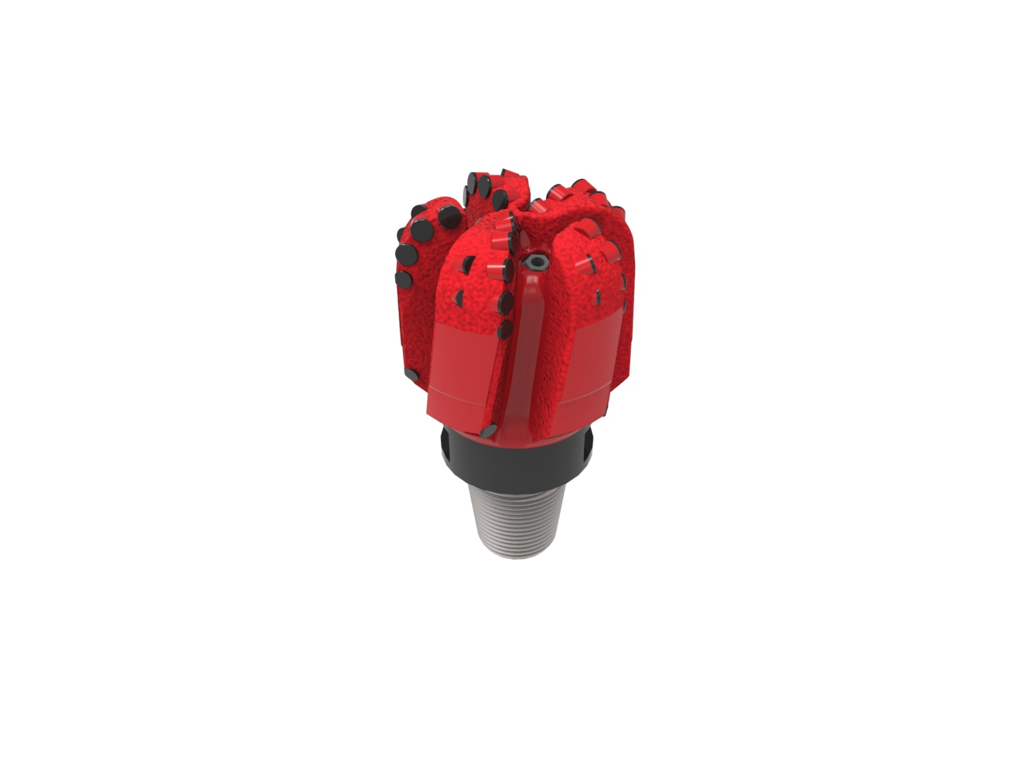
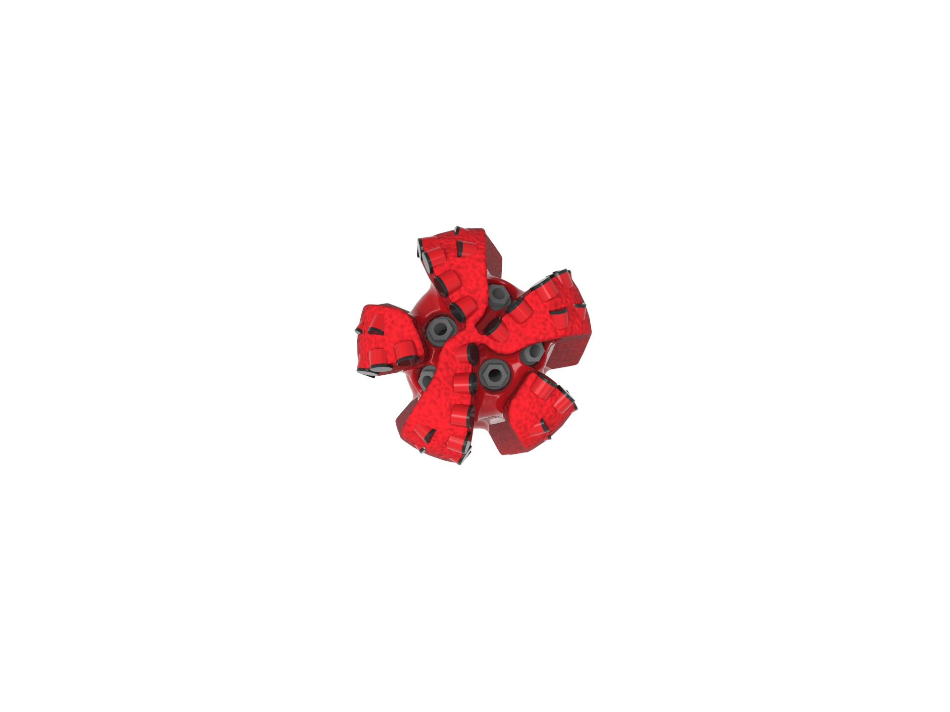

Drill Bit Specifications:
Cutter Size (Primary, Sec) | 5/8”,1/2”
Cutter Count (Total,Gage,Back Ream) | 39,5,5
Blade Count | 5
Gage Length (Inches) | 3.00
Nozzle Count (Primary, Sec.) | 5
Nozzle Series (Primary, Sec.) | 55
JSA (Sq. Inches) | 9.64
Max. TFA (Sq. Inches) | 0.98
Operating Parameters:
Max. Hydraulic Flow Rate (GPM) | 306
Max. Weight on Bit (1,000 Lbs.) | 22
Make-up Torque (ft/lbs) | 7,611
Nominal Dimensions:
Overall Length (Inches) | 12.26
Make Up Length (Inches) | 8.51
Bit Breaker | SKB-21012
Connection | Ø3-1/2" API Reg.
Approx. Weight (Lbs.) | 60

Standard Features:

- Customized gauge design for controlled directional response
- Large open face volume assists cuttings removal
- Five nozzles optimize blade cleaning and cuttings removal
- Premium grade cutters maximize ROP and Life

516-XR(BR) Nomenclature Explained:

• | 5 | = | Number of Blades
• | 16 | = | Primary Cutter Size (16mm)
• | XR+ | = | Backup Cutters
• | BR | = | Back Reaming Cutters


